Second-hand

While Justice Sleeps

[Stacey Abrams](https://bookshop.org/contributors/stacey-abrams) (Author)

[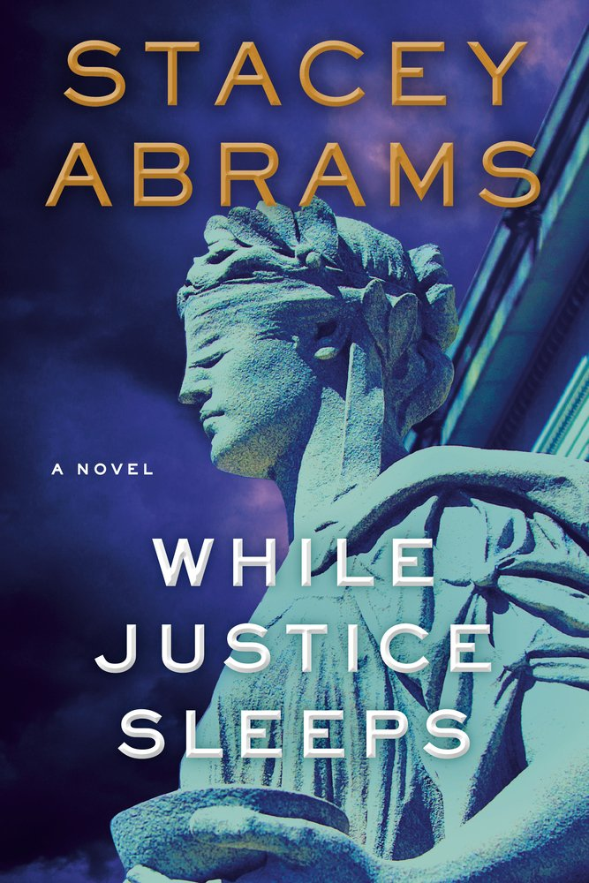](https://images-production.bookshop.org/spree/images/attachments/13315734/original/9780385546577.jpg?1612911606)

Description

INSTANT #1 NEW YORK TIMES BEST SELLER - From celebrated national leader and bestselling author Stacey Abrams, a gripping, complexly plotted thriller set within the halls of the U.S. Supreme Court.

Brilliant and mesmerizing. Abrams follows in Dan Brown's footprint with this masterfully plotted thriller that unfolds like the ultimate chess match--bold move to bolder move with lives hanging in the balance.--Lisa Gardner

Stacey Abrams is a true novelist, and While Justice Sleeps is a first-class legal thriller, favorably compared to many of the best, starting with The Pelican Brief, which it brings to mind. It's fast-paced and full of surprises--a terrific read.--Scott Turow

Avery Keene, a brilliant young law clerk for the legendary Justice Howard Wynn, is doing her best to hold her life together--excelling in an arduous job with the court while also dealing with a troubled family. When the shocking news breaks that Justice Wynn--the cantankerous swing vote on many current high-profile cases--has slipped into a coma, Avery's life turns upside down. She is immediately notified that Justice Wynn has left instructions for her to serve as his legal guardian and power of attorney. Plunged into an explosive role she never anticipated, Avery finds that Justice Wynn had been secretly researching one of the most controversial cases before the court--a proposed merger between an American biotech company and an Indian genetics firm, which promises to unleash breathtaking results in the medical field. She also discovers that Wynn suspected a dangerously related conspiracy that infiltrates the highest power corridors of Washington.

As political wrangling ensues in Washington to potentially replace the ailing judge whose life and survival Avery controls, she begins to unravel a carefully constructed, chesslike sequence of clues left behind by Wynn. She comes to see that Wynn had a much more personal stake in the controversial case and realizes his complex puzzle will lead her directly into harm's way in order to find the truth. While Justice Sleeps is a cunningly crafted, sophisticated novel, layered with myriad twists and a vibrant cast of characters. Drawing on her astute inside knowledge of the court and political landscape, Stacey Abrams shows herself to be not only a force for good in politics and voter fairness but also a major new talent in suspense fiction.

### Product Details

Price

~~$28.00~~  **$25.76**

Publisher

Doubleday Books

Publish Date

May 11, 2021

Pages

384

Dimensions

6.5 X 9.3 X 1.6 inches | 1.58 pounds

Language

English

Type

Hardcover

About the Author

Stacey Abrams is the two-time New York Times bestselling author of Our Time Is Now and Lead from the Outside, an entrepreneur, and a political leader. A tax attorney by training, she served eleven years in the Georgia House of Representatives, seven as Minority Leader, and became the 2018 Democratic nominee for governor of Georgia, where she won more votes than any other Democrat in the state's history. She has launched multiple organizations devoted to voting rights, training and hiring young people of color, and tackling social issues at the state, national, and international levels. She is the founder of Fair Fight, Fair Count, and the Southern Economic Advancement Project. Abrams is a lifetime member of the Council on Foreign Relations and sits on the advisory board of Climate Power 2020 and the advocacy board of the Women's National Basketball Players Association. She has received degrees from Spelman College, the LBJ School of Public Affairs at the University of Texas, and Yale Law School.

The Anthropocene Reviewed (Signed Edition): Essays on a Human-Centered Planet

[John Green](https://bookshop.org/contributors/john-green-24abaaa5-c5a3-45ef-8ccd-ac1e891434f4) (Author)

[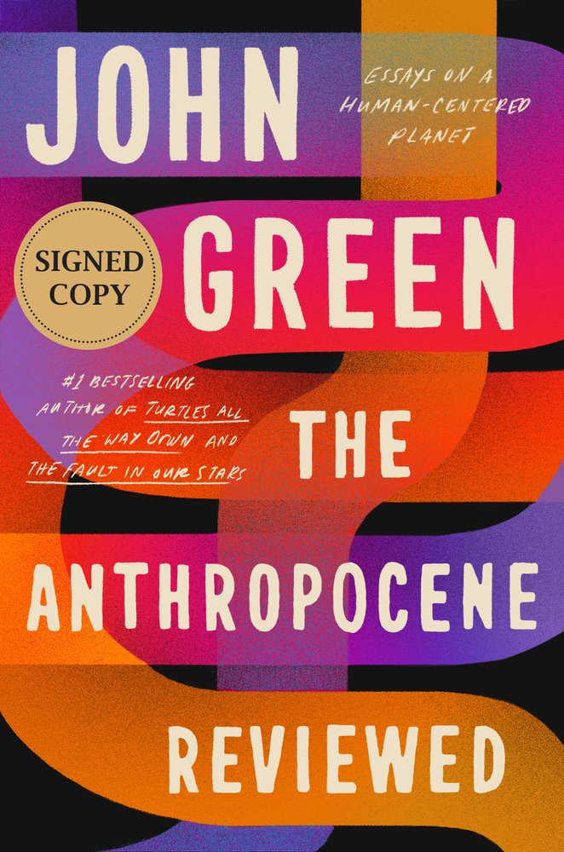](https://images-production.bookshop.org/spree/images/attachments/13175664/original/9780525555216.jpg?1621617809)

Description

A deeply moving collection of personal essays from John Green, the #1 bestselling author of The Fault in Our Stars and Turtles All the Way Down.  
  
"The perfect book for right now." -People  
  
"Makes the wondrous small ... and the small wondrous." -San Francisco Chronicle

The Anthropocene is the current geologic age, in which humans have profoundly reshaped the planet and its biodiversity. In this remarkable symphony of essays adapted and expanded from his groundbreaking podcast, bestselling author John Green reviews different facets of the human-centered planet on a five-star scale--from the QWERTY keyboard and sunsets to Canada geese and Penguins of Madagascar.

Funny, complex, and rich with detail, the reviews chart the contradictions of contemporary humanity. As a species, we are both far too powerful and not nearly powerful enough, a paradox that came into sharp focus as we faced a global pandemic that both separated us and bound us together.

John Green's gift for storytelling shines throughout this masterful collection. The Anthropocene Reviewed is a open-hearted exploration of the paths we forge and an unironic celebration of falling in love with the world.

This is a signed edition.

### Product Details

Price

~~$28.00~~  **$25.76**

Publisher

Dutton Books

Publish Date

May 18, 2021

Pages

320

Language

English

Type

Hardcover

About the Author

John Green is the award-winning, #1 bestselling author of books including Looking for Alaska, The Fault in Our Stars, and Turtles All the Way Down. His books have received many accolades, including a Printz Medal, a Printz Honor, and an Edgar Award. John has twice been a finalist for the LA Times Book Prize and was selected by TIME magazine as one of the 100 Most Influential People in the World. He is also the writer and host of the critically acclaimed podcast The Anthropocene Reviewed. With his brother, Hank, John has co-created many online video projects, including Vlogbrothers and the educational channel Crash Course. He lives with his family in Indianapolis, Indiana. You can visit John online at johngreenbooks.com.

One Last Stop

[Casey McQuiston](https://bookshop.org/contributors/casey-mcquiston) (Author)

[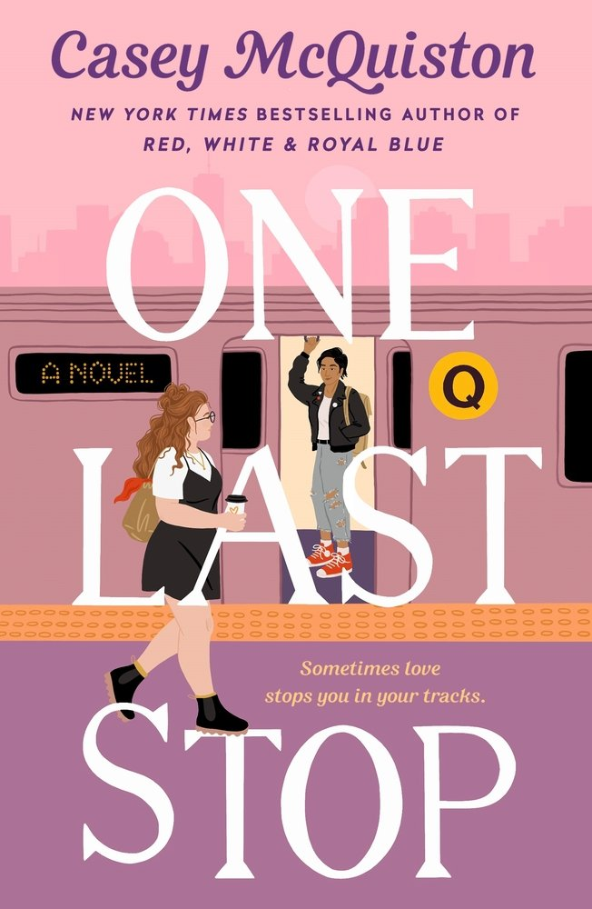](https://images-production.bookshop.org/spree/images/attachments/13076611/original/9781250244499.jpg?1612290032)

Description

From the New York Times bestselling author of Red, White & Royal Blue comes a new romantic comedy that will stop readers in their tracks...  
  
Dreamy, other worldly, smart, swoony, thoughtful, hilarious - all in all, exactly what you'd expect from Casey McQuiston! - Jasmine Guillory, New York Times bestselling author of The Proposal and Party for Two  
  
For cynical twenty-three-year-old August, moving to New York City is supposed to prove her right: that things like magic and cinematic love stories don't exist, and the only smart way to go through life is alone. She can't imagine how waiting tables at a 24-hour pancake diner and moving in with too many weird roommates could possibly change that. And there's certainly no chance of her subway commute being anything more than a daily trudge through boredom and electrical failures.

But then, there's this gorgeous girl on the train.

Jane. Dazzling, charming, mysterious, impossible Jane. Jane with her rough edges and swoopy hair and soft smile, showing up in a leather jacket to save August's day when she needed it most. August's subway crush becomes the best part of her day, but pretty soon, she discovers there's one big problem: Jane doesn't just look like an old school punk rocker. She's literally displaced in time from the 1970s, and August is going to have to use everything she tried to leave in her own past to help her. Maybe it's time to start believing in some things, after all.

Casey McQuiston's One Last Stop is a magical, sexy, big-hearted romance where the impossible becomes possible as August does everything in her power to save the girl lost in time.

A dazzling romance, filled with plenty of humor and heart. - Time Magazine, The 21 Most Anticipated Books of 2021

### Product Details

Price

~~$16.99~~  **$15.63**

Publisher

St. Martin's Griffin

Publish Date

June 01, 2021

Pages

432

Dimensions

5.4 X 8.3 X 1.1 inches | 0.8 pounds

Language

English

Type

Paperback

About the Author

Casey McQuiston is the New York Times bestselling author of Red, White & Royal Blue, as well as a pie enthusiast. She writes books about smart people with bad manners falling in love. Born and raised in southern Louisiana, she now lives in New York City with her poodle mix and personal assistant, Pepper.

Best Wishes, Warmest Regards: The Story of Schitt's Creek

[Eugene Levy](https://bookshop.org/contributors/eugene-levy) (Author)  [Daniel Levy](https://bookshop.org/contributors/daniel-levy-b7ecdce4-a202-4a39-bfbe-1d6a83940ea6) (Author)

[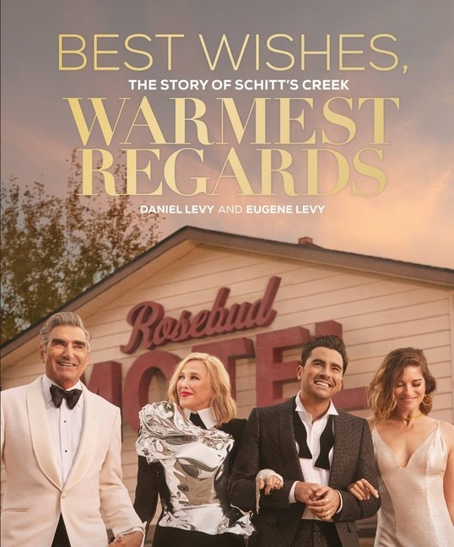](https://images-production.bookshop.org/spree/images/attachments/14465108/original/9780762499502.jpg?1621946750)

Description

The official tie-in book for the beloved, nine-time Emmy(R) Award-winning series Schitt's Creek.

This beautifully produced, keepsake coffee-table book is the ultimate celebration of the series, the town, the characters, and the state of mind that is Schitt's Creek. Capturing the essence and alchemy of all six seasons of what is now considered to be one of the most groundbreaking comedy television series of the last decade, Best Wishes, Warmest Regards is a gift to fans everywhere who have made the show their own.

Included are character profiles from the cast of Johnny, Moira, David, and Alexis, and all of the characters that populate the town, major moments from Moira's endorsement of Herb Ertlinger Winery, to Patrick and David's first kiss, to Cabaret and the Rose Family Christmas episode. Also included are special features, such as the complete, illustrated catalogs of David's knits and Moira's wigs, Moira's vocabulary, Alexis's adventures, and behind-the-scenes moments from Dan and Eugene Levy and the cast of Schitt's Creek.

### Product Details

Price

~~$40.00~~  **$36.80**

Publisher

Black Dog & Leventhal Publishers

Publish Date

October 26, 2021

Pages

368

Language

English

Type

Hardcover

About the Author

Daniel Levy is an Emmy(R) winning showrunner, writer, actor, director, and producer, best known for his work on Schitt's Creek, which he co-created with his father Eugene Levy. For its sixth and final season, the series received nine Emmy(R) wins, becoming the most awarded comedy series in a single year. The show also broke major records for being the first comedy or drama series to sweep all four acting categories and received the most wins for a comedy series in its final season. Levy and his father were also the first father-son pair to win Emmys in the same year and Levy tied the record for most wins by an individual in a single season with four total wins. Levy began his television career co-hosting MTV Canada's flagship show MTV Live. In 2019, Levy signed a multi-year overall deal with Disney's ABC Studios to develop and produce scripted projects for the studio. Recently, Levy starred alongside Bette Midler, Kailtyn Dever, Sarah Paulson, and Issa Rae in Coastal Elites on HBO and appeared in the romantic comedy Happiest Season for TriStar Pictures and Entertainment One. Most recently, Levy made his hosting debut on Saturday Night Live in early 2021.

Eugene Levy is an Emmy(R) winning, actor, producer and writer. He is best known for his work on Schitt's Creek, which earned him two Emmy(R) awards for Best Comedy Actor and Best Comedy Series. He also has appeared in more than 60 motion pictures to date, eight of which having topped the $100M mark, including Bringing Down The House, Cheaper By the Dozen 2, and Father Of The Bride Part II. But it was the role of Noah Levenstein in the American Pie franchise that cemented his reputation as America's favorite Dad. Partnering with Christopher Guest, Levy earned critical acclaim for co-writing and co-starring in Best In Show, Waiting For Guffman, For Your Consideration, and A Mighty Wind. Levy has been nominated for and won countless awards for his films including a New York Film Critics Circle Award and a Grammy Award(R) for A Mighty Wind and a Golden Globe(R) nomination for Best In Show. Levy is a Member of the Order of Canada and a recipient of The Governor General's Performing Arts Award, the foremost Canadian honor for excellence in the performing arts.

The 1619 Project: A New Origin Story

[The New York Times Magazine](https://bookshop.org/contributors/the-new-york-times-magazine) (Editor)  [Nikole Hannah-Jones](https://bookshop.org/contributors/nikole-hannah-jones) (Editor)

[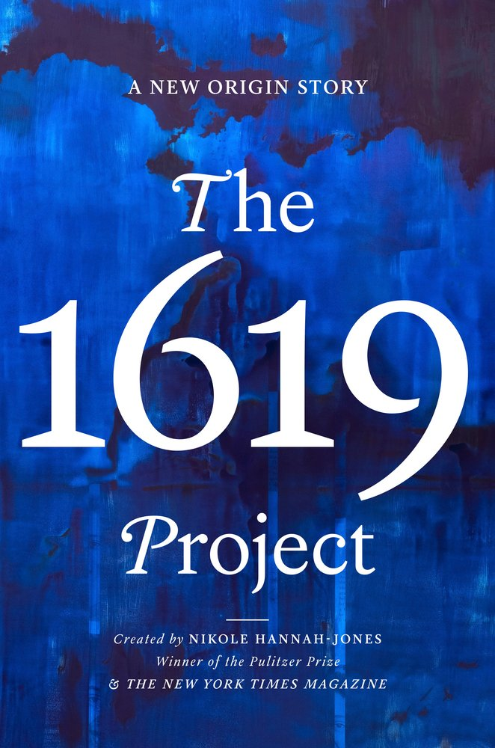](https://images-production.bookshop.org/spree/images/attachments/14210335/original/9780593230572.jpg?1621621724)

Description

A dramatic expansion of a groundbreaking work of journalism, The 1619 Project: A New Origin Story offers a profoundly revealing vision of the American past and present.  
  
In late August 1619, a ship arrived in the British colony of Virginia bearing a cargo of twenty to thirty enslaved people from Africa. Their arrival led to the barbaric and unprecedented system of American chattel slavery that would last for the next 250 years. This is sometimes referred to as the country's original sin, but it is more than that: It is the source of so much that still defines the United States.

The New York Times Magazine's award-winning "1619 Project" issue reframed our understanding of American history by placing slavery and its continuing legacy at the center of our national narrative. This new book substantially expands on that work, weaving together eighteen essays that explore the legacy of slavery in present-day America with thirty-six poems and works of fiction that illuminate key moments of oppression, struggle, and resistance. The essays show how the inheritance of 1619 reaches into every part of contemporary American society, from politics, music, diet, traffic, and citizenship to capitalism, religion, and our democracy itself.

This is a book that speaks directly to our current moment, contextualizing the systems of race and caste within which we operate today. It reveals long-glossed-over truths around our nation's founding and construction--and the way that the legacy of slavery did not end with emancipation, but continues to shape contemporary American life.

### Product Details

Price

~~$30.00~~  **$27.60**

Publisher

One World

Publish Date

November 16, 2021

Pages

512

Language

English

Type

Hardcover

About the Author

Nikole Hannah-Jones is a Pulitzer Prize-winning reporter covering racial injustice for The New York Times Magazine, and creator of the landmark 1619 Project. In 2017, she received a MacArthur Foundation Fellowship, known as the Genius Grant, for her work on educational inequality. She has also won a Peabody Award, two George Polk Awards, three National Magazine Awards, and the 2018 John Chancellor Award for Excellence in Journalism from Columbia University. In 2016, Hannah-Jones co-founded the Ida B. Wells Society for Investigative Reporting, a training and mentorship organization geared toward increasing the number of investigative reporters of color.

The 1619 Project is an ongoing initiative from The New York Times Magazine that began in August 2019, the four hundredth anniversary of the beginning of American slavery. It is led by Pulitzer Prize-winning journalist Nikole Hannah-Jones, along with New York Times Magazine editor-in-chief Jake Silverstein, Ilena Silverman, and Caitlin Roper.